

TOPIC: WEEKLY WORK REPORT
NAME:ADVANCED WEB
COURSE: BACHELOR OF SCIENCE IN INFORMATION TECHNOLOGY
DEPARTMENT: COMPUTING AND INFORMATICS

STUDENT DETAILS:
Student name : Mike Momanyi
Admission number:BSCCS/2024/57241
Course: BACHELOR OF SCIENCE IN INFORMATION TECHNOLOGY
Unit code:BIT3208
Unit Name:Advanced web design
Semester: 3.2
LECTURER : MICHAEL NYORO
Table of Contents
WEEK 1: Local environment setup 4
Installation and Testing of Local Development Environment 4
TESTING FOR HELLO WORLD IN PHP PAGE : 5
DATABASE CONNECTION TEST: 5
MY REFLECTION: 6
WEEK 2 : Wireframes and GUI Design 6
User interface planning and system design 6
Fig 1: Hand-drawn Wireframe 6
Fig 2: Dashboard Layout Design 8
Fig 3: Mobile View Mockup 9
Fig 4: Color Theme and Navigation Structure 10
Fig 5: GUI Prototype in Figma/Canva/Draw.io 11
MY Reflection: 12
WEEK 3 : JavaScript and PHP Basics 13
Frontend Interaction and Backend Foundations 13
Fig 1: JavaScript Form Validation 13
Fig 2: Password Strength Checker 14
Fig 3: PHP Syntax Practice 14
Fig 4: Database Connection Script 15
Fig 5: Dynamic User Input Handling 16
17
18
19
20
MY Reflection: 20
Week 4: Server-Side Components and Backend Development Foundations 21
Task 1 – Understanding Server-Side Programming 21
Simple PHP processing page 21
Dynamic welcome page 21
Form submission system 21
Task 2 – HTML Forms and PHP Integration 23
Registration form 23
Login form 24
Contact form 25
Task 3 – Simple Authentication System 26
Basic login page 26
Username/password valid 27
Session-based welcome page 28
Task 4 – Backend Folder Organization 28
Folder structure 28
Database connection 29
My Reflection 29
Week 5:Database Components and CRUD Operations 30
Database screenshot 30
Table creation screenshots 31
CRUD operation screenshots 32
SQL query screenshots 33
My Reflection 35
Week 6: Database Integration and CRUD Operations 36
CRUD OPERATIONS 36
Register accounts 36
View information 36
Remove unwanted records 37
Edit records 37
Database Integration 38
My Reflection 38
Week 7: User Authentication and Session Management 39
Role-based login 39
Different dashboards 39
User dashboard 39
Admin dashboard 40
Session management 40
My Reflection 40
Week 8 Notes: Responsive Web Design and Mobile-First Development 41
Smartphone 41
Tablet 41
Laptop 42
GitHub updates 42

WEEK 1: Local environment setup

Installation and Testing of Local Development Environment
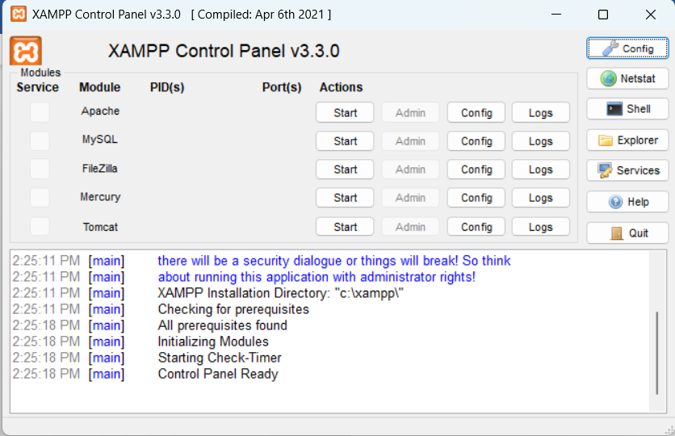

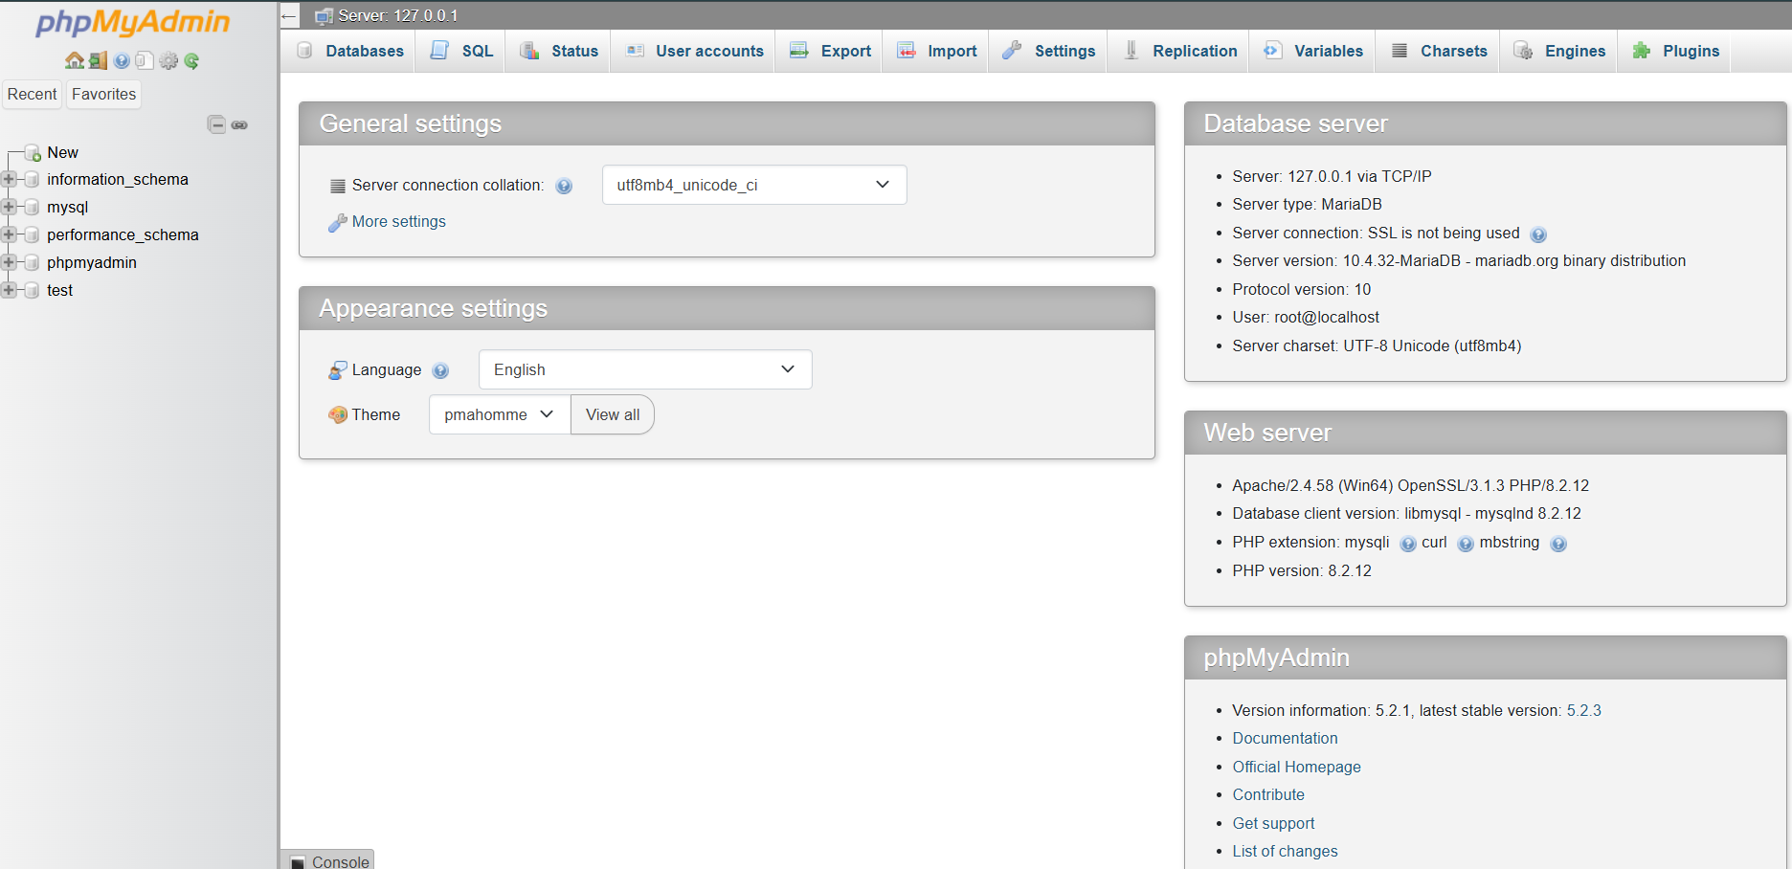

TESTING FOR HELLO WORLD IN PHP PAGE :
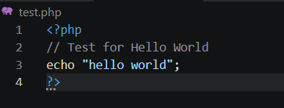

DATABASE CONNECTION TEST:
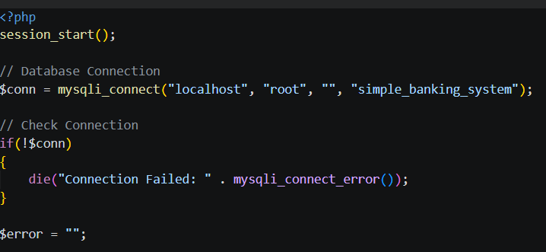
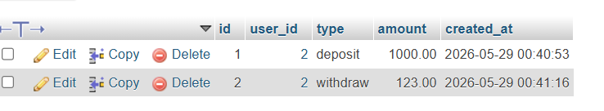

MY REFLECTION:
-During this setup, I learned how to configure a local web development environment using XAMPP, Apache, PHP, and MySQL. Fig 1 confirms successful installation of XAMPP, while Fig 2 demonstrates that Apache and MySQL services were running correctly. Fig 3 shows successful access of the localhost server through a web browser. Fig 4 verifies that the PHP environment was functioning properly using a Hello World test page. Fig 5 confirms successful database connectivity between PHP and MySQL using mysqli_connect().

WEEK 2 : Wireframes and GUI Design

User interface planning and system design

Fig 1: Hand-drawn Wireframe
(Login/Homepage)
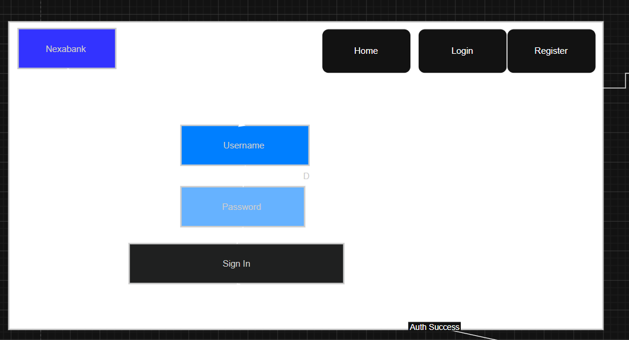

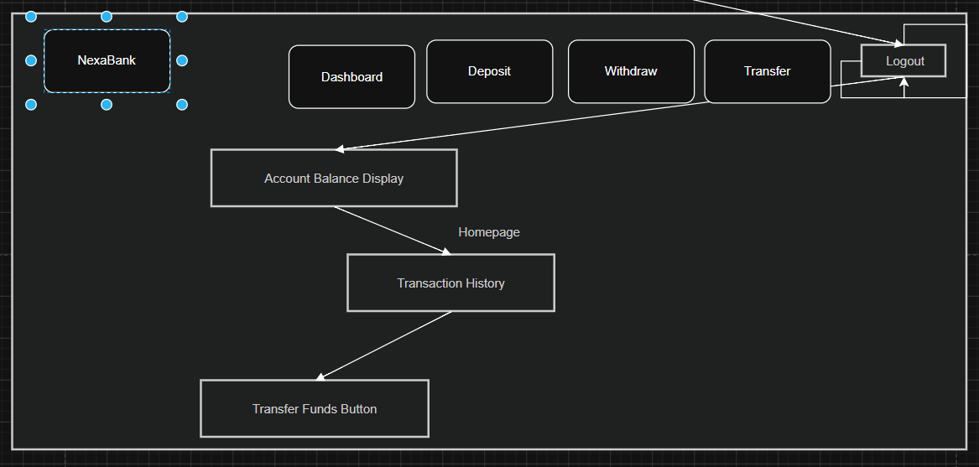

Fig 2: Dashboard Layout Design

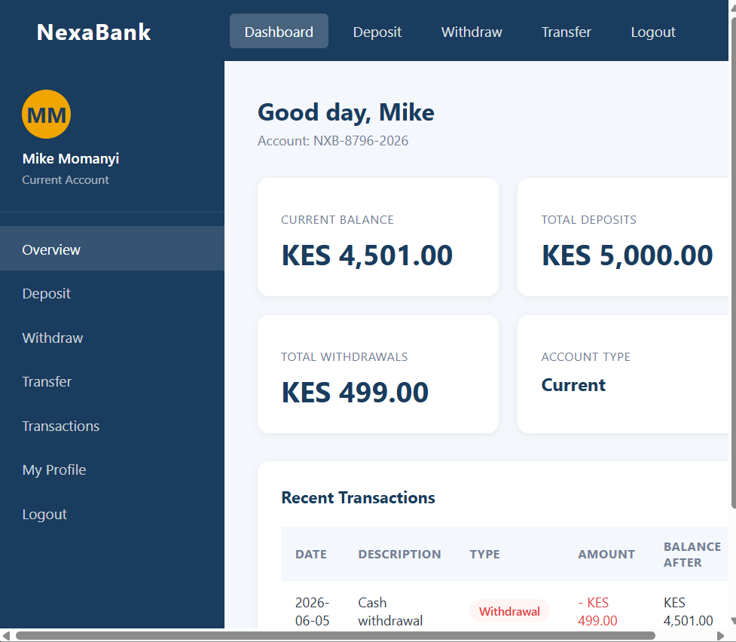

Fig 3: Mobile View Mockup

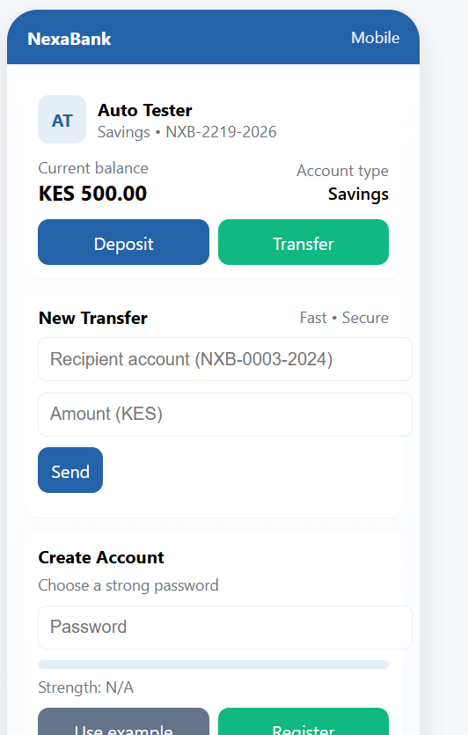

Fig 4: Color Theme and Navigation Structure

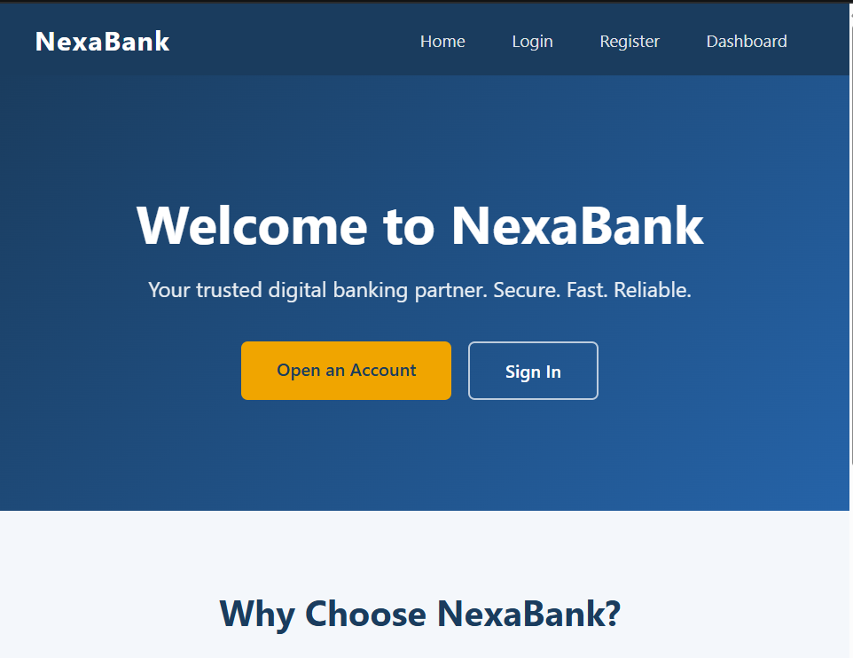

Fig 5: GUI Prototype in Figma/Canva/Draw.io

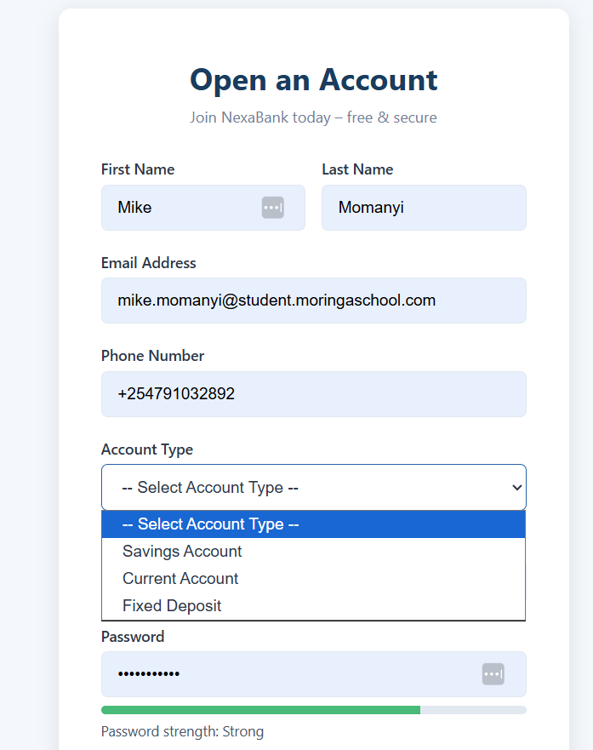

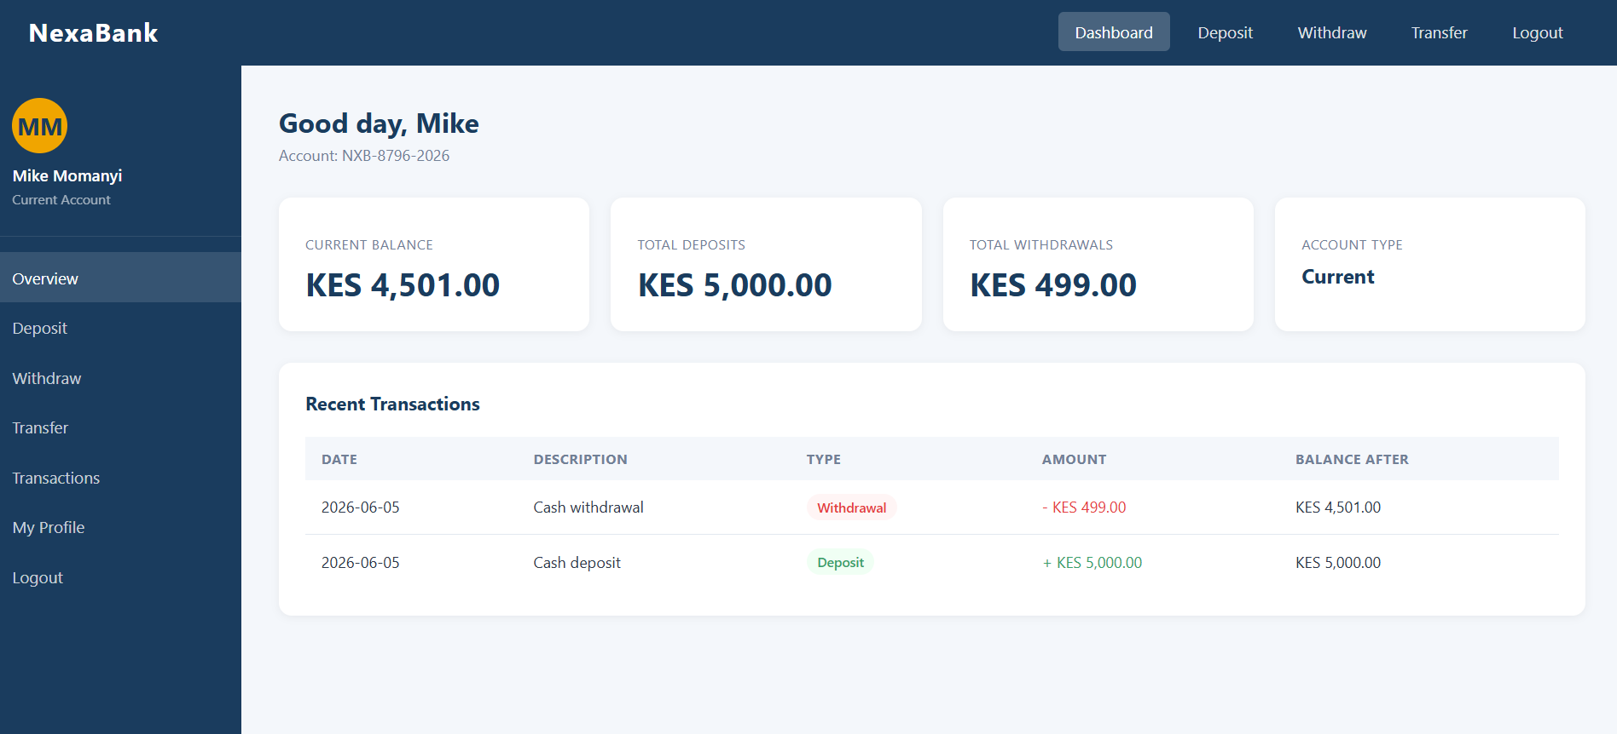

MY Reflection:
-The simple banking system design was selected to provide an easy and user-friendly interface for customers and administrators. The dashboard layout was organized clearly to help users access features such as account balance, deposits, withdrawals, and transaction history with minimal clicks. Mobile view mockups were included to ensure the system remains responsive on smartphones and tablets. The navigation structure was planned to improve movement between pages without confusion. The selected color theme improved readability and professionalism. The GUI prototype created in Figma helped visualize the final system before development and ensured the design met user requirements effectively.

WEEK 3 : JavaScript and PHP Basics

Frontend Interaction and Backend Foundations

Fig 1: JavaScript Form Validation

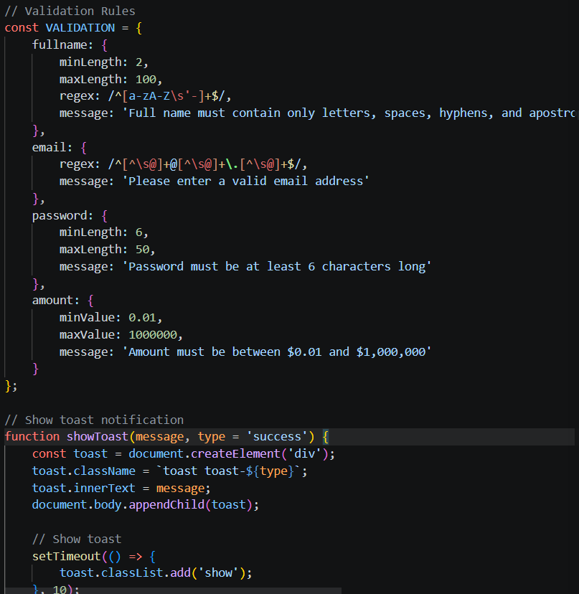

Fig 2: Password Strength Checker

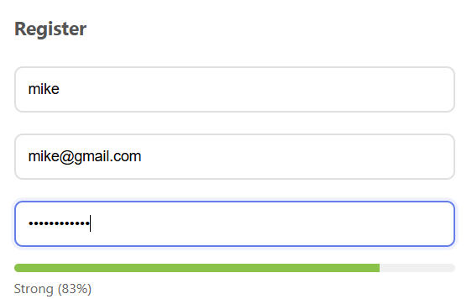

Fig 3: PHP Syntax Practice

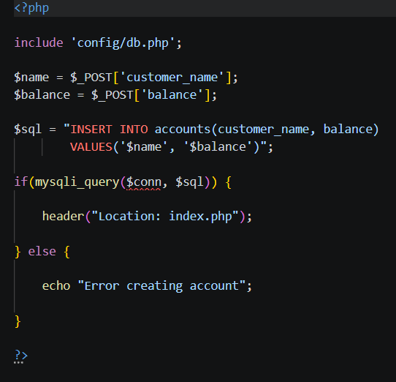

Fig 4: Database Connection Script

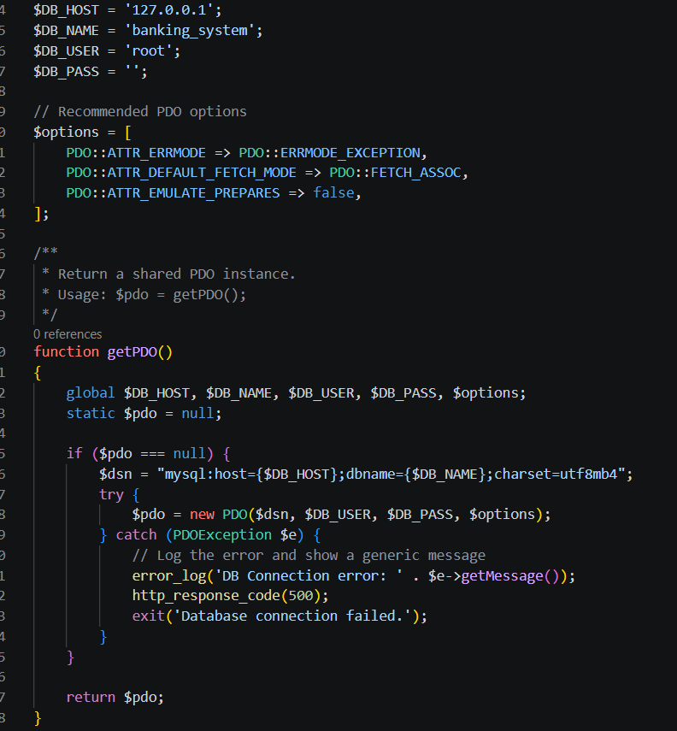

Fig 5: Dynamic User Input Handling

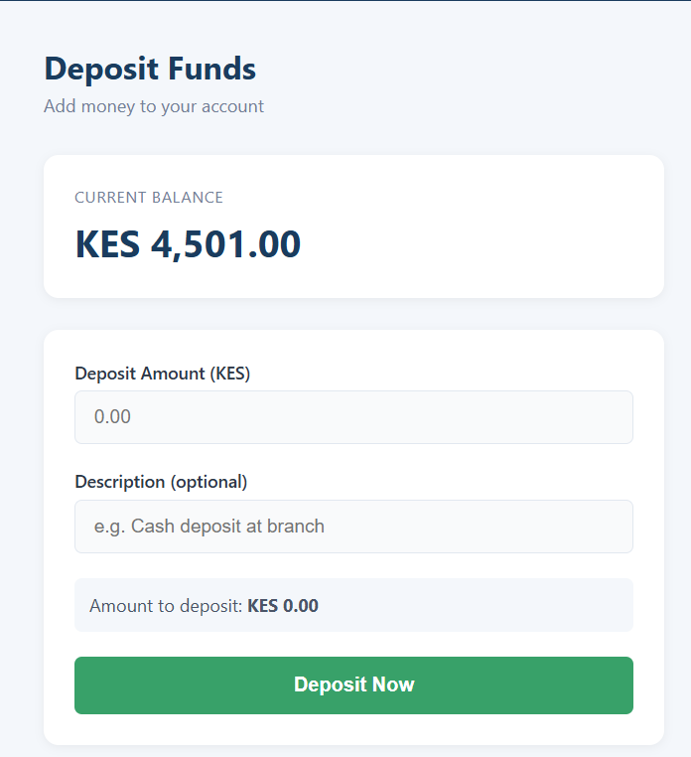

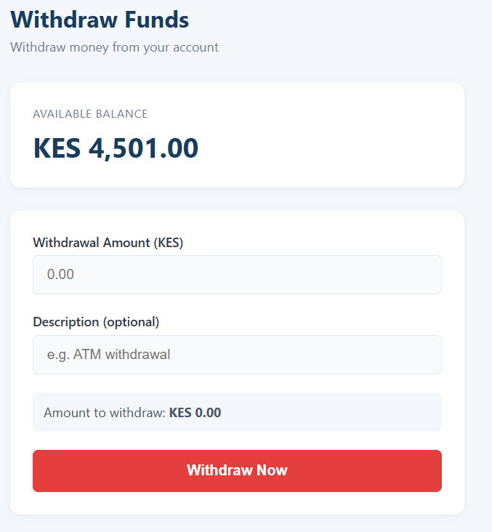

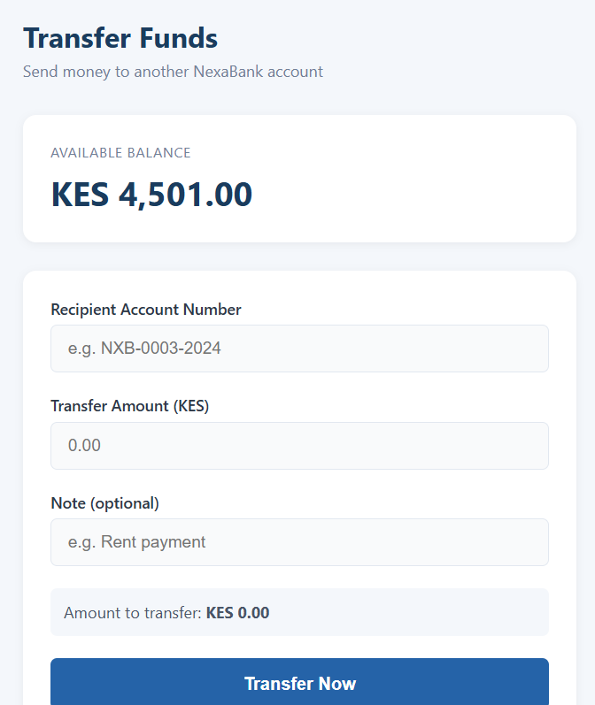

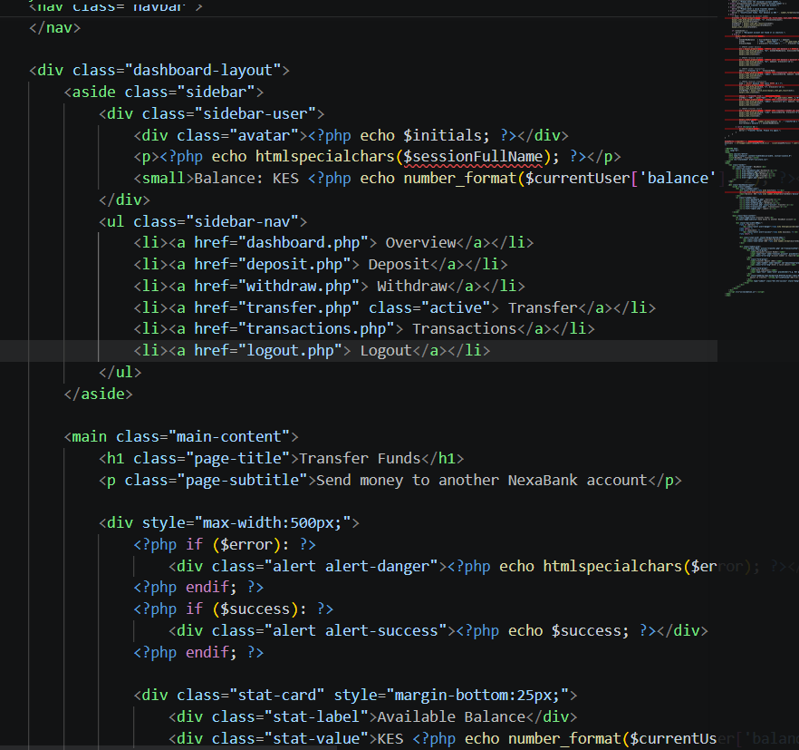

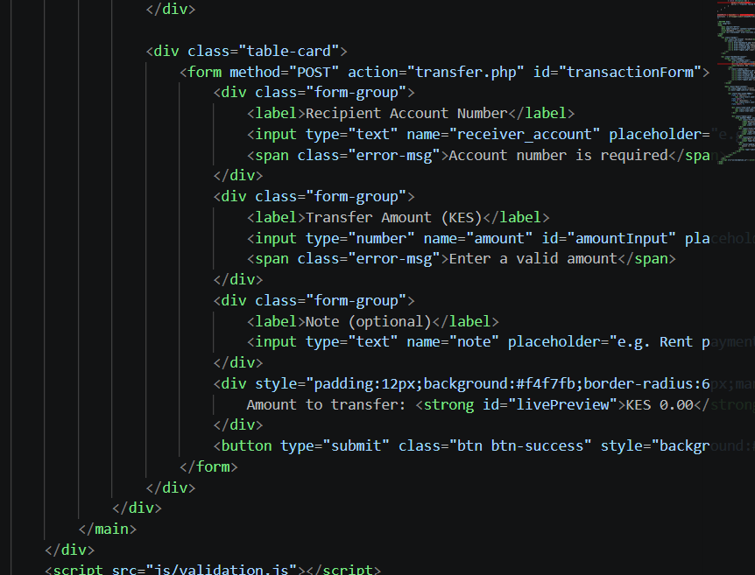

MY Reflection:
-The simple banking system demonstrated interaction between frontend and backend technologies using HTML, JavaScript, PHP, and MySQL. JavaScript validation was implemented to prevent empty or incorrect form submissions before data reached the server. The password strength checker improved account security by guiding users to create stronger passwords. PHP scripts processed user requests and handled communication with the database. The database connection script confirmed successful integration between PHP and MySQL for storing and retrieving user records. Dynamic user input handling allowed users to perform transactions and view account details efficiently. The screenshots show system development progress, backend integration, and successful user interaction flow also shows the code snippets.

Week 4: Server-Side Components and Backend Development Foundations
-Introducing dynamic backend processing and real user interaction systems.

Task 1 – Understanding Server-Side Programming

Simple PHP processing page

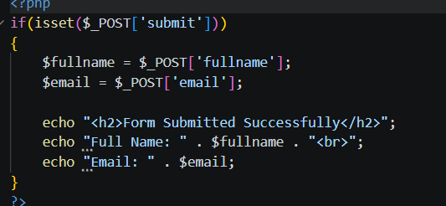

Dynamic welcome page
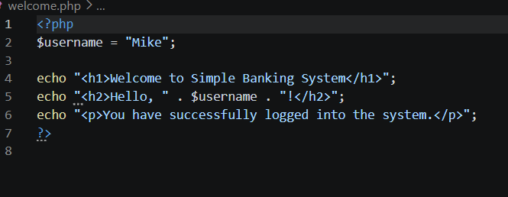

Form submission system

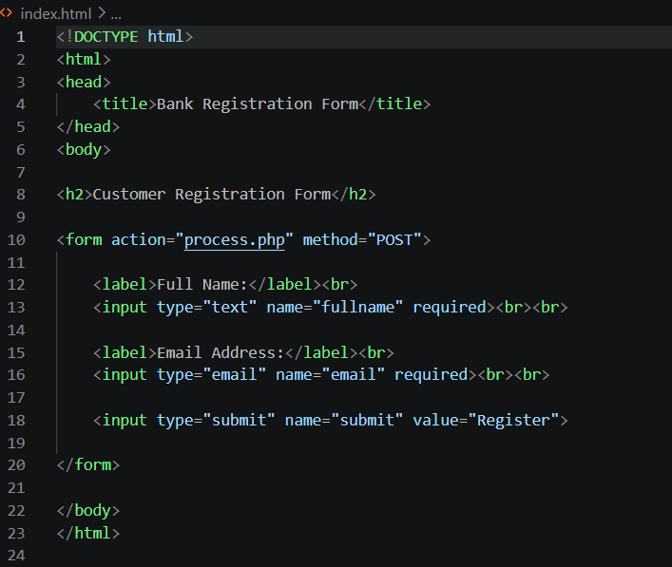

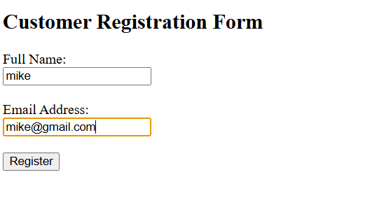
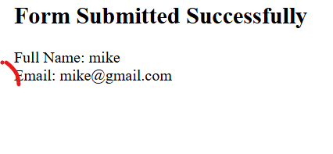

Task 2 – HTML Forms and PHP Integration

Registration form
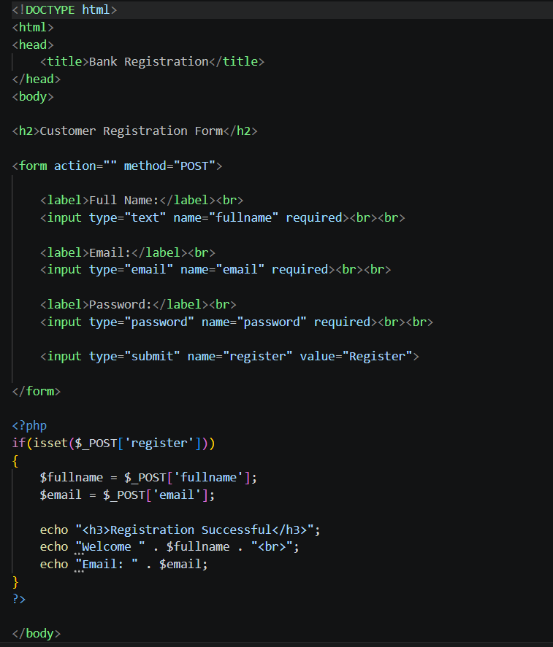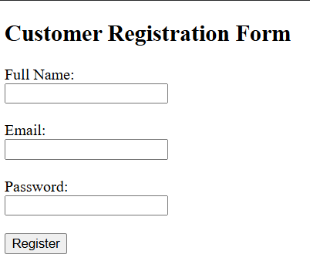

Login form
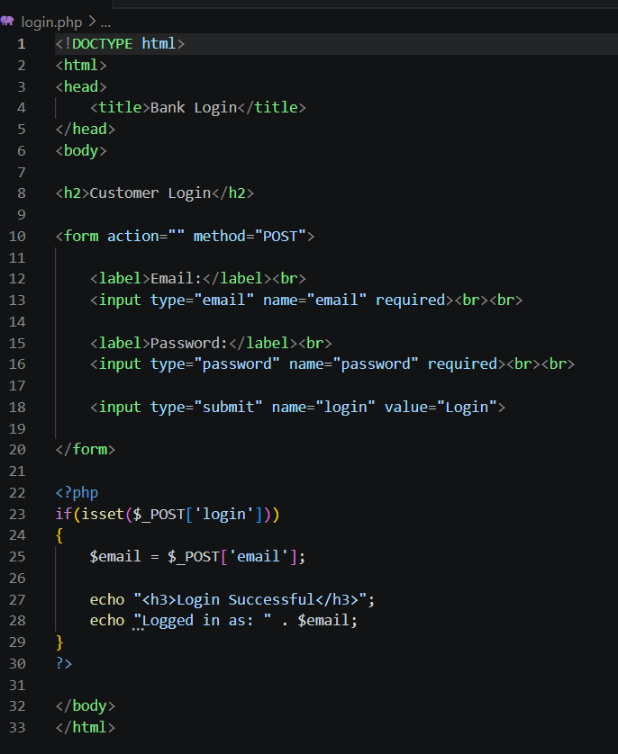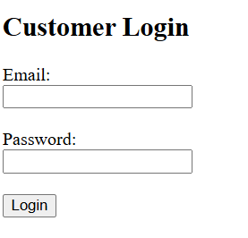

Contact form
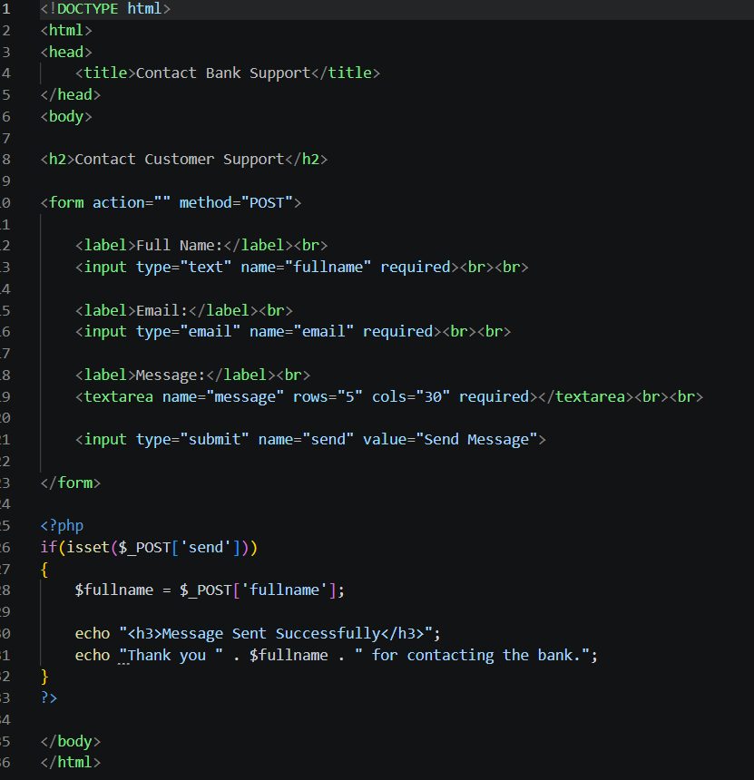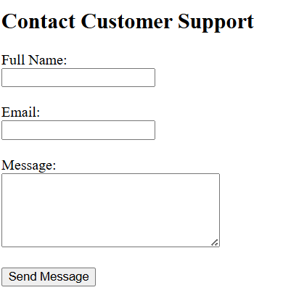

Task 3 – Simple Authentication System

Basic login page
- 
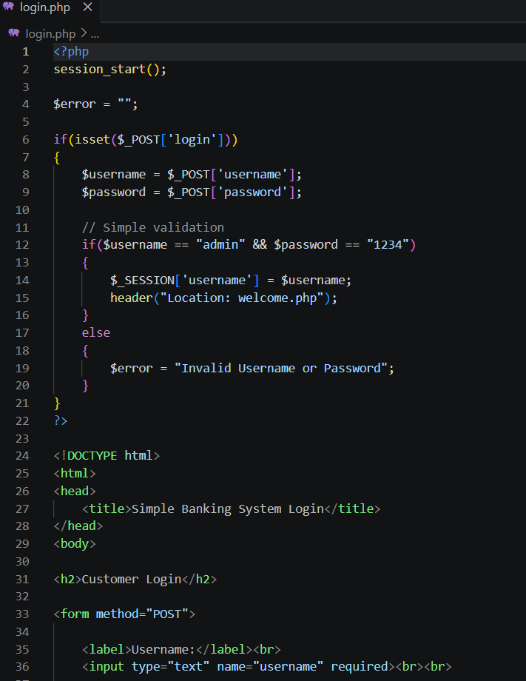

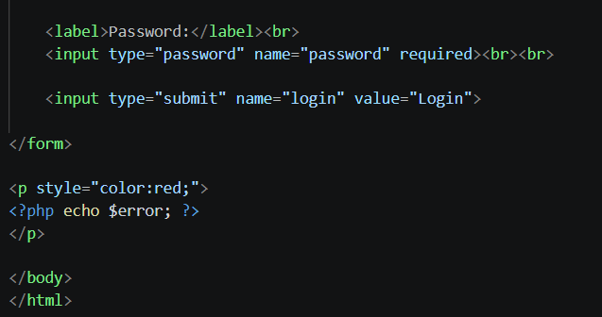

Username/password valid
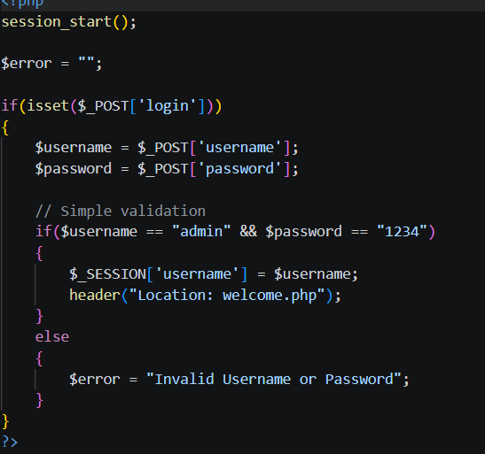

Session-based welcome page
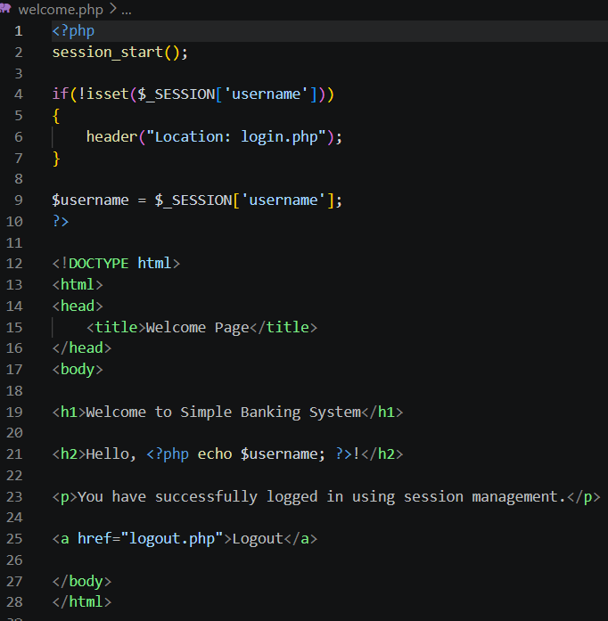

Task 4 – Backend Folder Organization

Folder structure
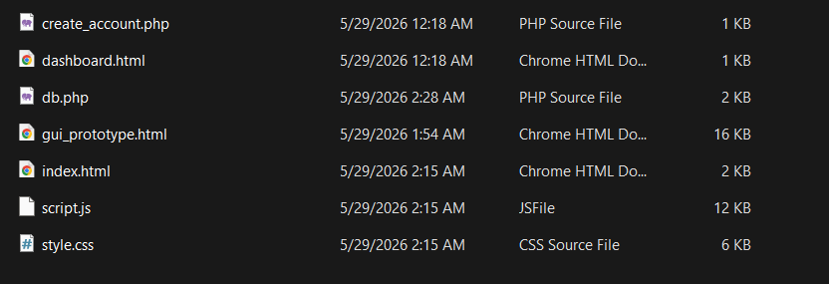

Database connection
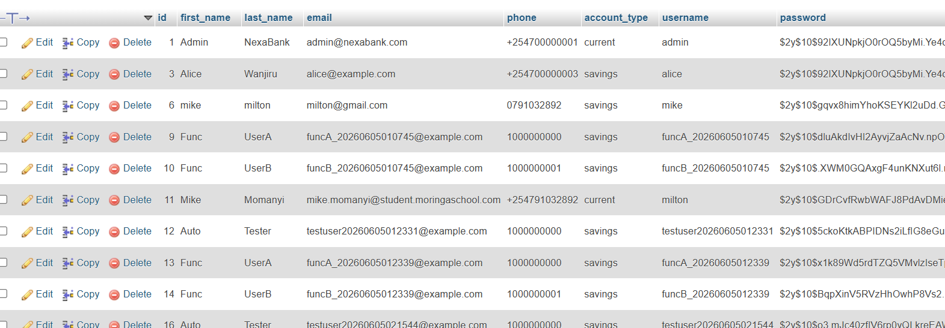

My Reflection
This lesson on Server-Side Components and Backend Development Foundations helped me understand how web applications process data and communicate with databases. I learned the importance of server-side scripting, handling user requests, and managing application logic securely. The practical exercises improved my confidence in developing dynamic web applications and connecting them to databases. Although some concepts were challenging at first, consistent practice made them easier to understand. Overall, this module strengthened my foundation in backend development and prepared me for more advanced web development topics.

Week 5:Database Components and CRUD Operations

Database screenshot
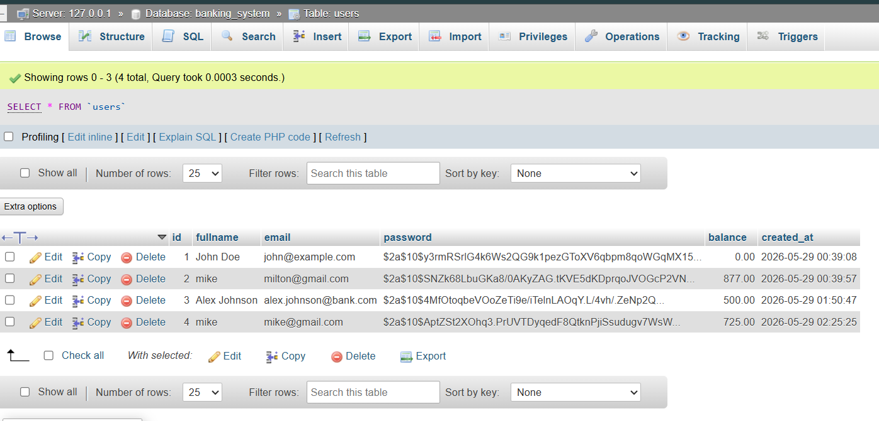

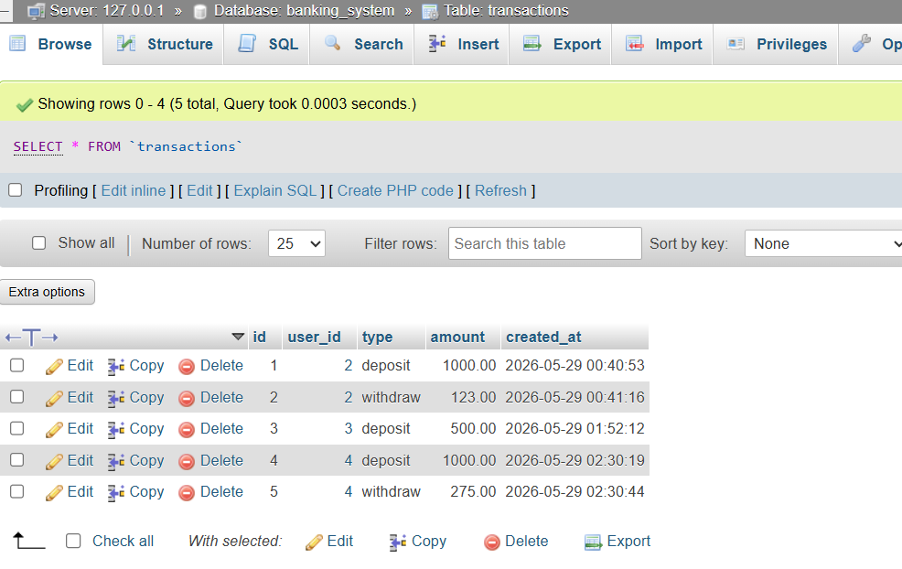

Table creation screenshots
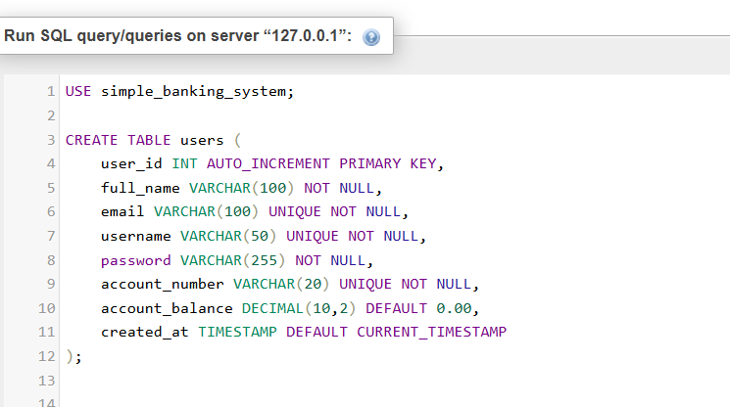

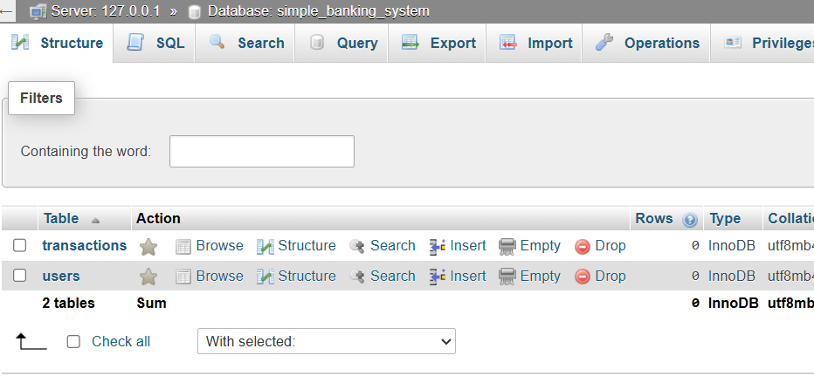

CRUD operation screenshots
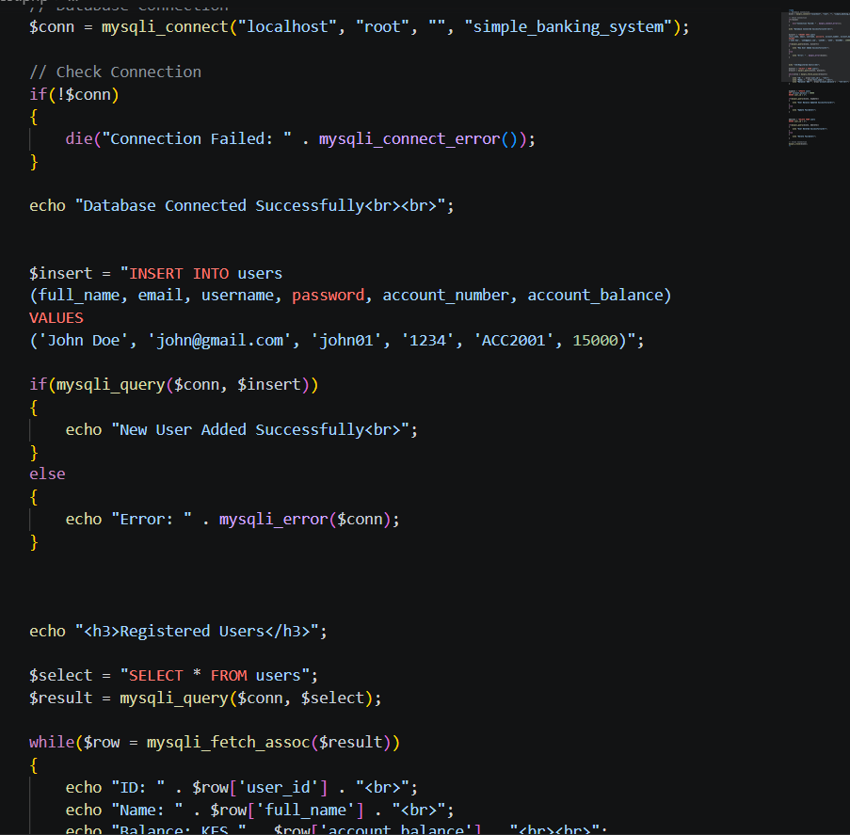
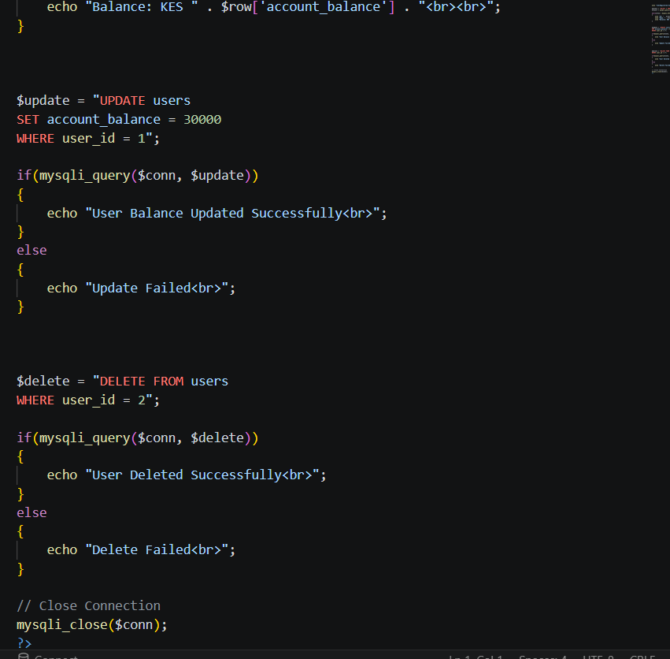

SQL query screenshots


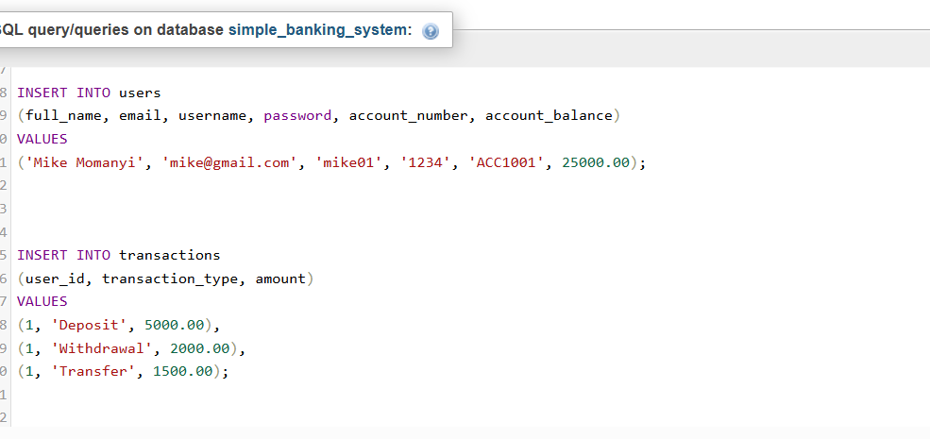
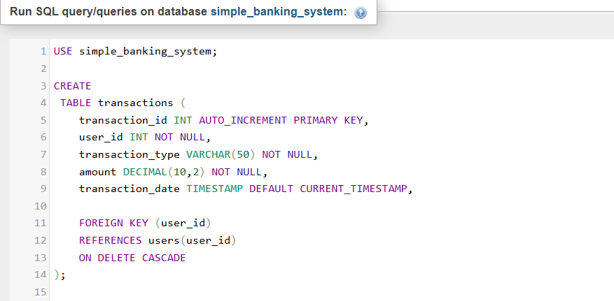

My Reflection
The topic on Database Components and CRUD Operations gave me a better understanding of how databases are designed and managed in web applications. I learned how to create, read, update, and delete records using SQL, which are essential operations in database management. The practical exercises helped me understand how backend applications interact with databases to store and retrieve information. Although writing SQL queries required careful attention to detail, regular practice improved my confidence. Overall, this topic strengthened my database management skills and prepared me to build data-driven applications.

Week 6: Database Integration and CRUD Operations

CRUD OPERATIONS

Register accounts
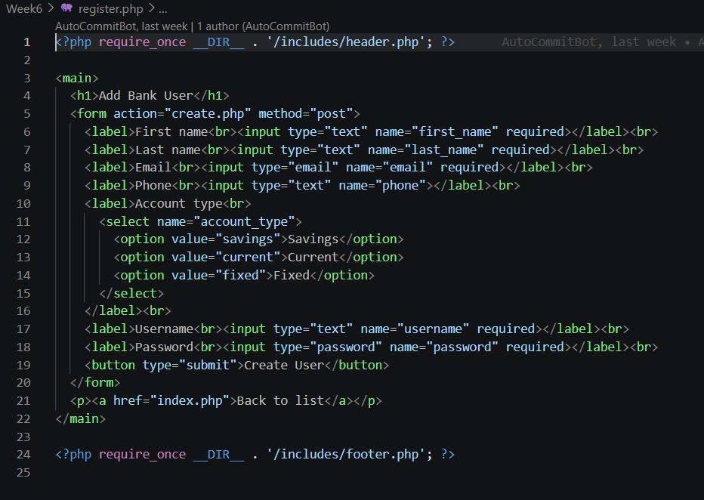

View information
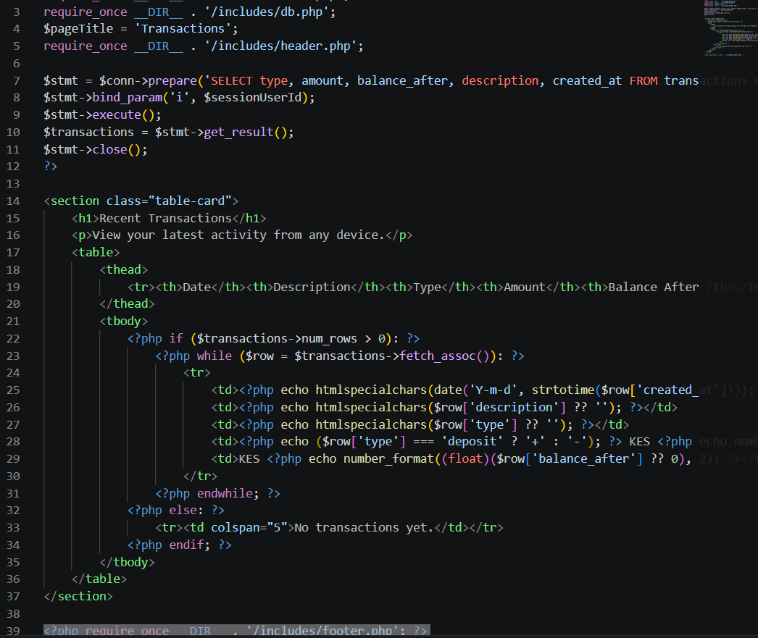

Remove unwanted records
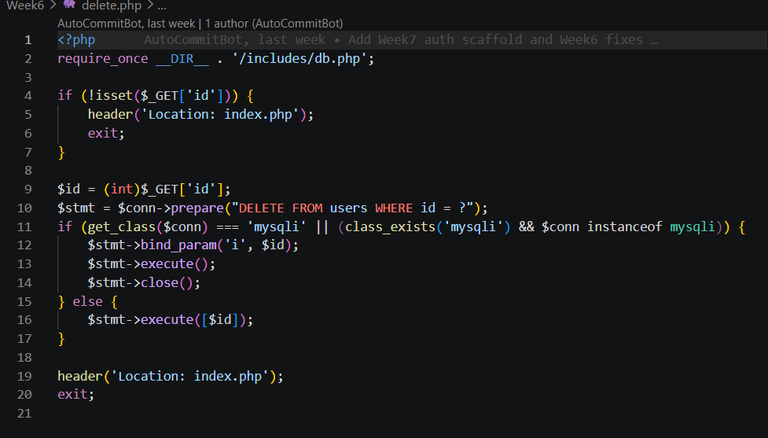
Edit records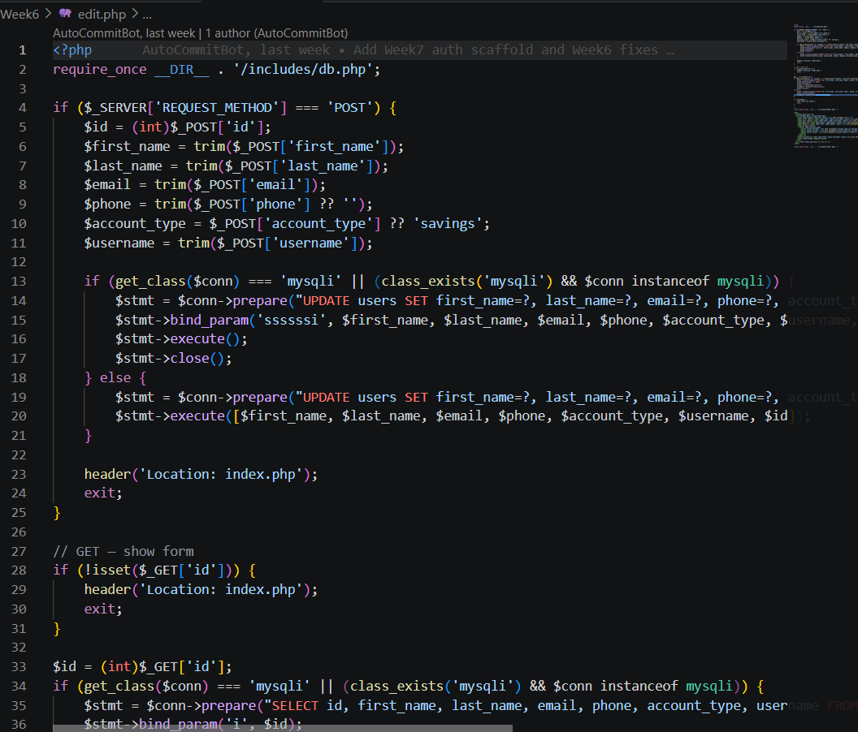

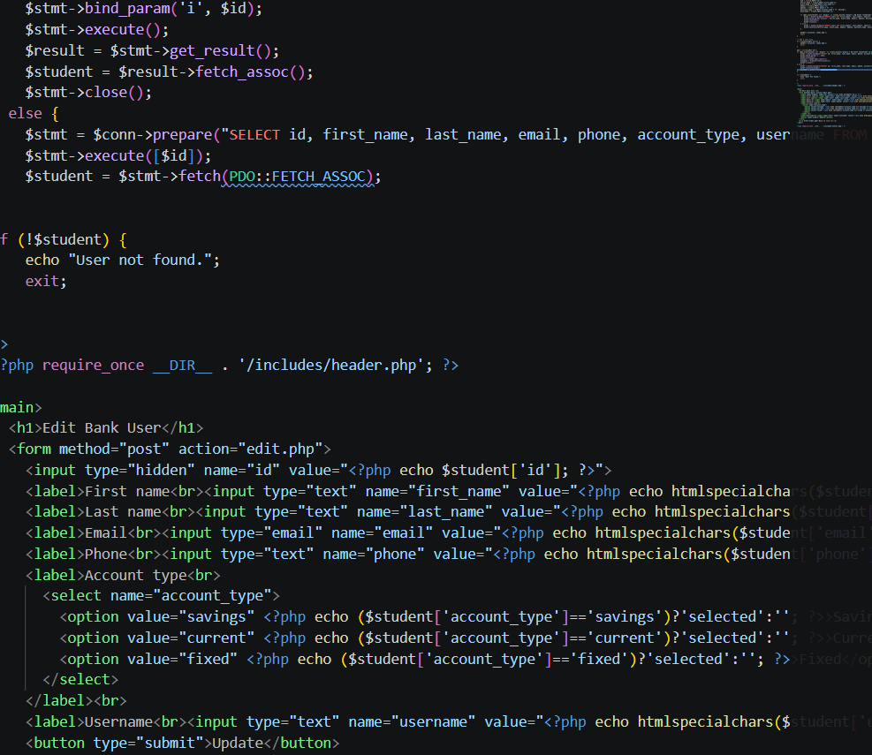

Database Integration

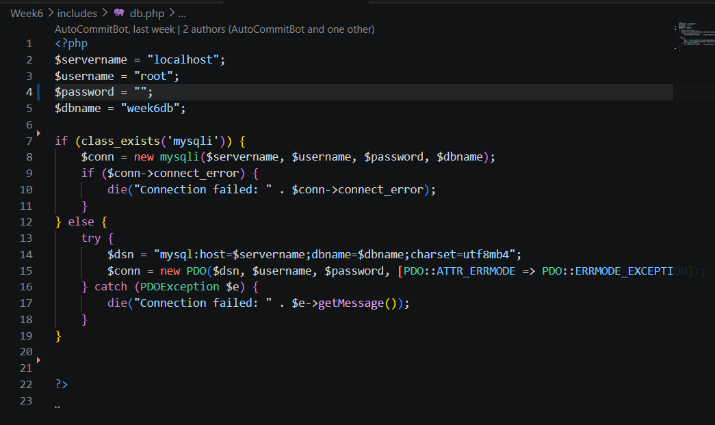
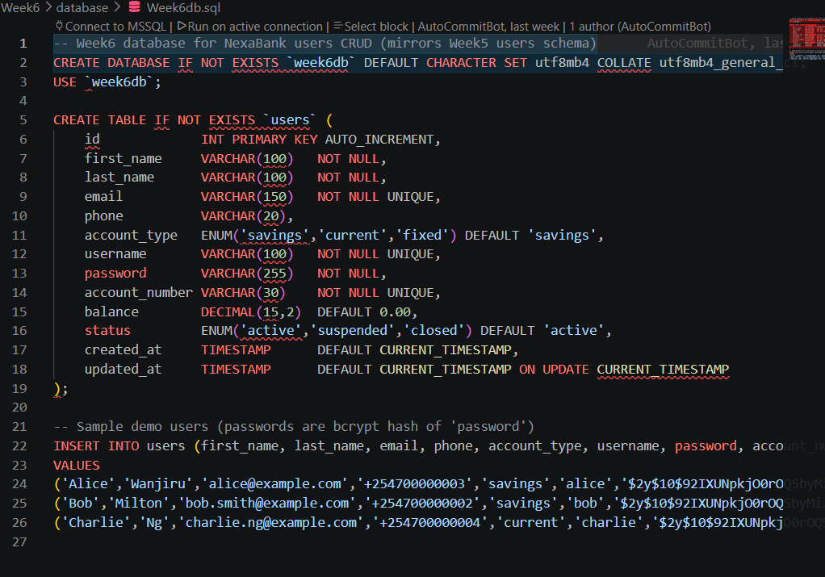

My Reflection
Database Integration and CRUD Operations enhanced my understanding of how web applications connect to databases and manage data efficiently. I learned how to integrate a database with a backend application and perform Create, Read, Update, and Delete (CRUD) operations using server-side code. The practical activities improved my ability to build dynamic applications that can store, retrieve, and update information securely. While troubleshooting database connections and queries was sometimes challenging, it helped me develop better problem-solving skills. Overall, this topic strengthened my confidence in developing database-driven web applications.

Week 7: User Authentication and Session Management

Role-based login
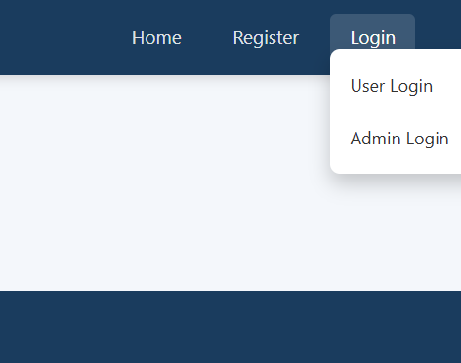

Different dashboards

User dashboard
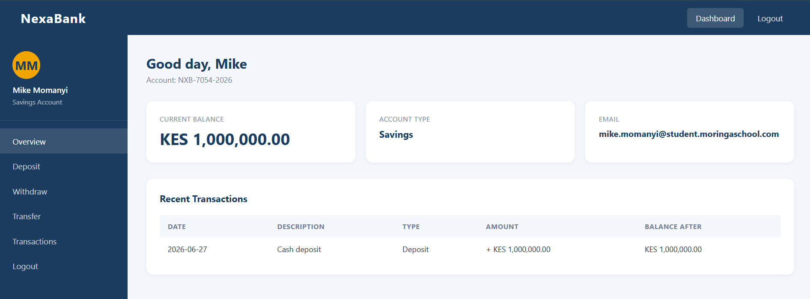

Admin dashboard
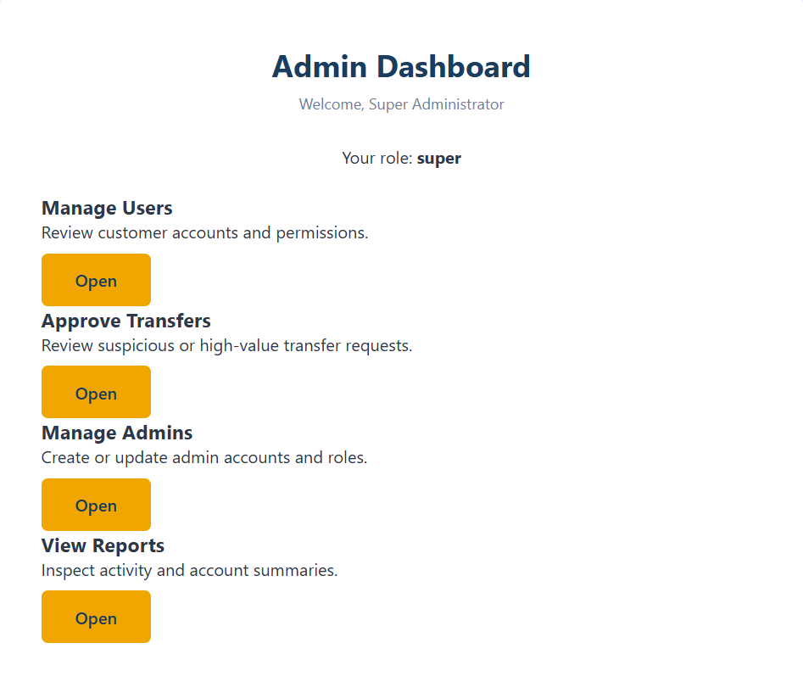

Session management
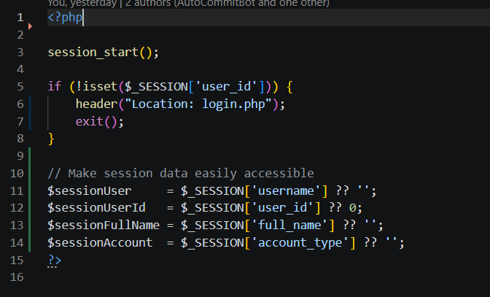

My Reflection
The topic on User Authentication and Session Management helped me understand how web applications verify users and protect their accounts. I learned how to implement user login, password validation, and session management to maintain secure access after authentication. The practical exercises improved my understanding of handling user credentials and restricting access to authorized users. Although managing sessions and security features required careful implementation, the experience strengthened my backend development skills. Overall, this topic increased my confidence in building secure and reliable web applications.

Week 8 Notes: Responsive Web Design and Mobile-First Development

Smartphone
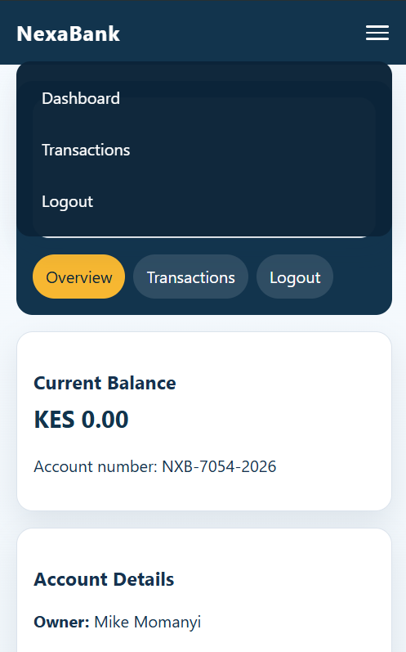

Tablet
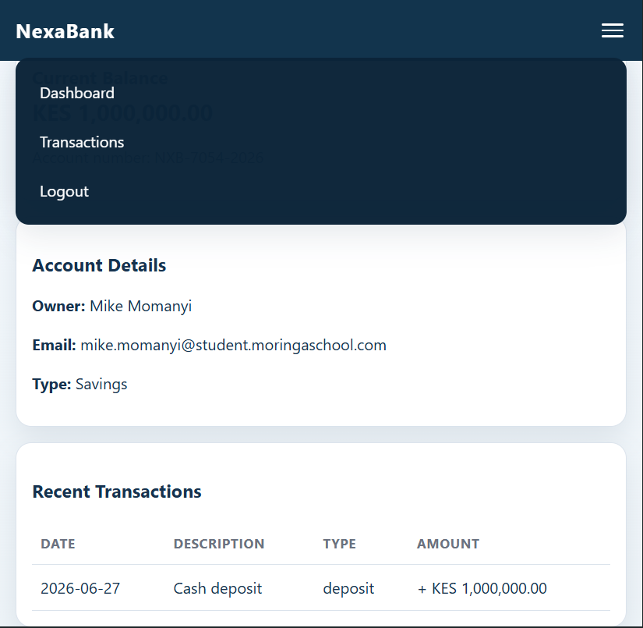

Laptop
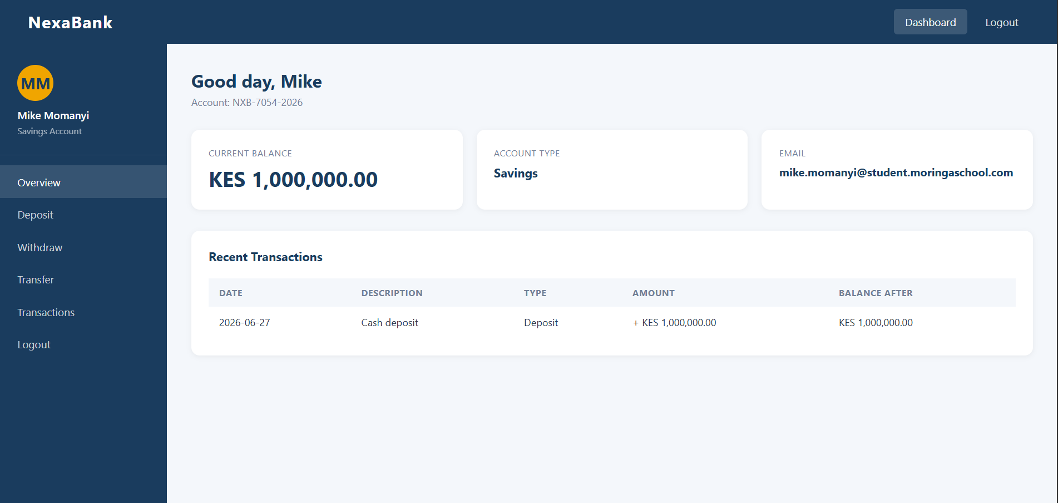

GitHub updates
https://github.com/Hami-bit/NexaBank/tree/main

